### **chatbot to shop for essentials during pandemic using Watson Assistant**

**Introduction of chatbot –**

A chatbot is a software application used to conduct an on-line chat conversation via text or text-to-speech, in lieu of providing direct contact with a live human agent. Designed to convincingly simulate the way a human would behave as a conversational sexual partner, chatbot systems typically require continuous tuning and testing, and many in production remain unable to adequately converse or pass the industry standard Turing test. The term "ChatterBot" was originally coined by Michael Mauldin (creator of the first Verbot) in 1994 to describe these conversational programs.

**How it helpful –**

Chatbot applications streamline interactions between people and services, enhancing customer experience. At the same time, they offer companies new opportunities to improve the customers engagement process and operational efficiency by reducing the typical cost of customer service.

**Project Description:**

Today, because of social distancing and other issues it can be risky for some people to shop for essential items in person. This project helps with this issue by giving people an online option to shop for essentials. With the help of Watson assistant, a chatbot is built. This chat should have the following capabilities:

1. Give the list of items in the Store
2. Should show the  prices of vegetables
3. Display if there are any offers or discounts
4. The bot should be able to take details like name, contact number, address, and the items to place the order.

**Services Used:**

1. IBM Watson Assistant
2. Node-Red

**Architecture:**

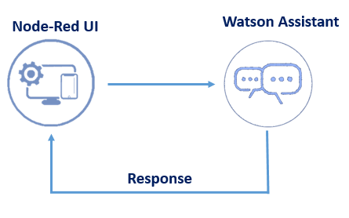

**Screenshots**

Create dialog for the project

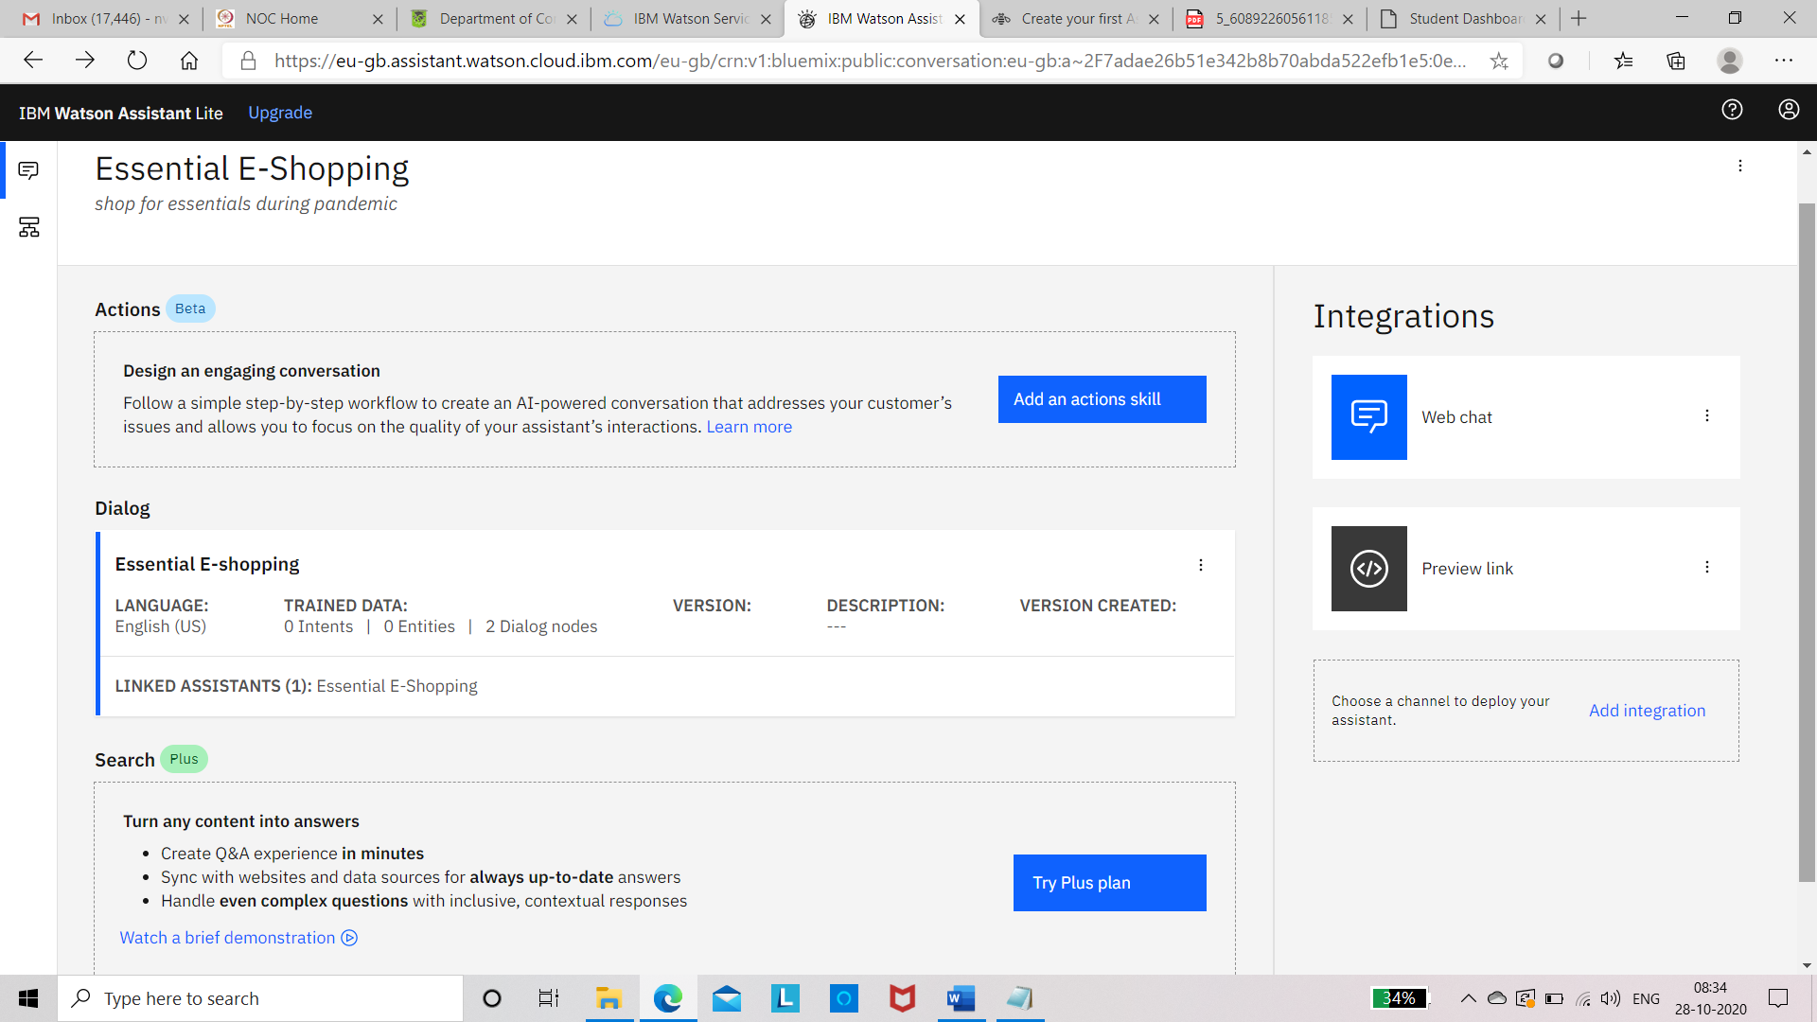

**Click on Essential E-shopping dialog and we will get following screen**

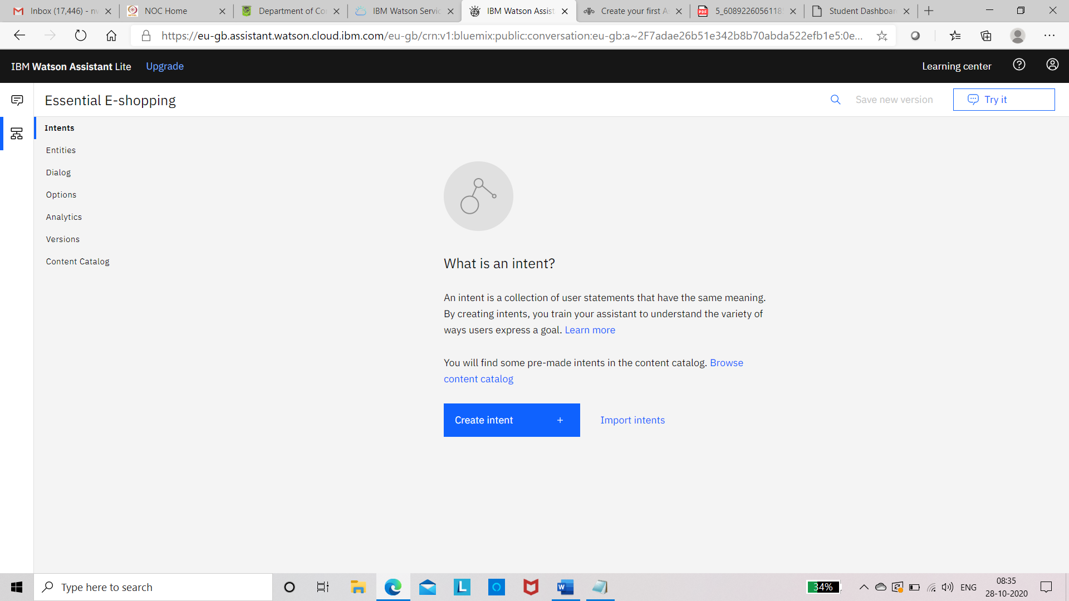

**Click on intent and create necessary intents**

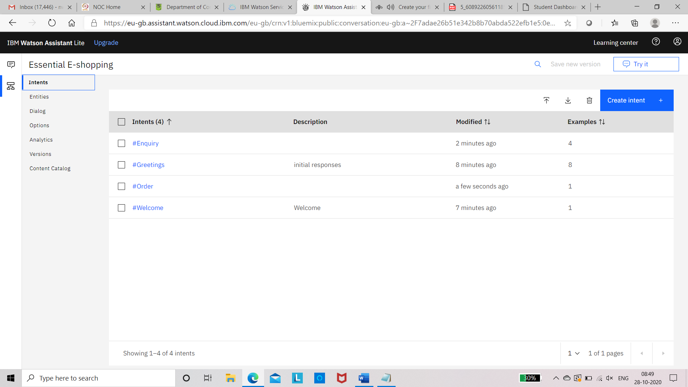

**Create entities**

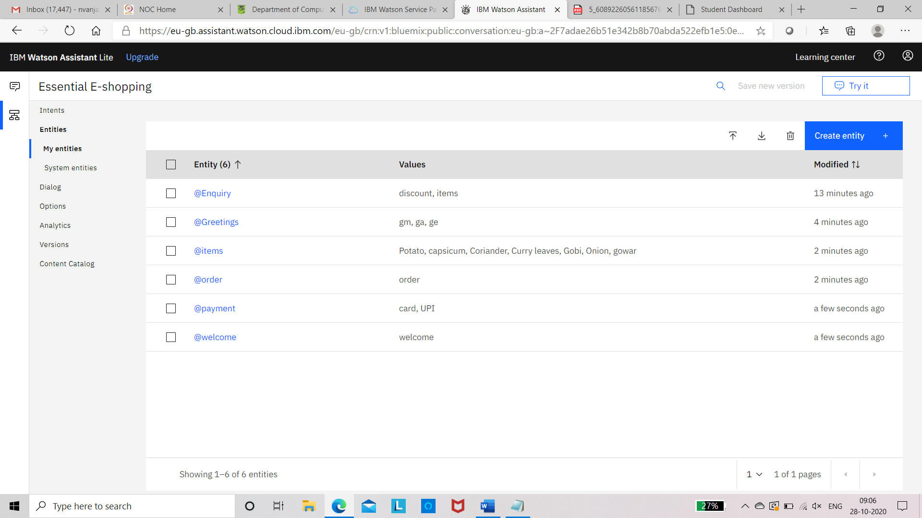 **System entities**

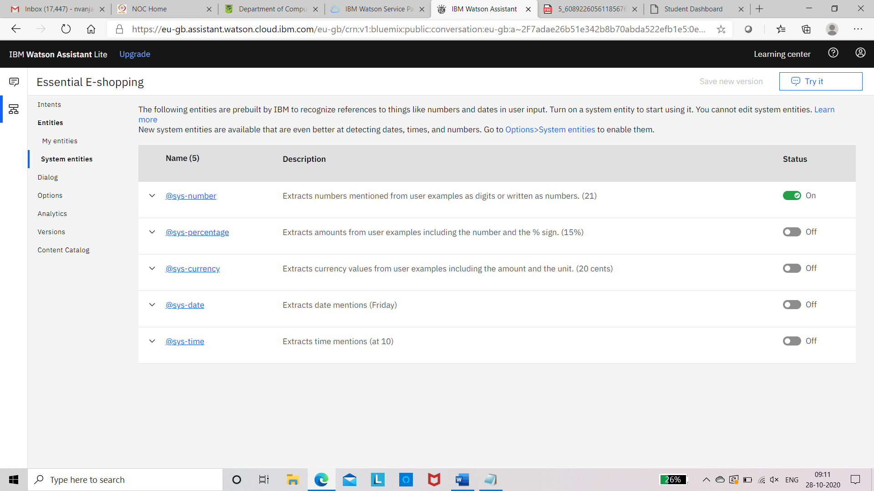

Dialogues

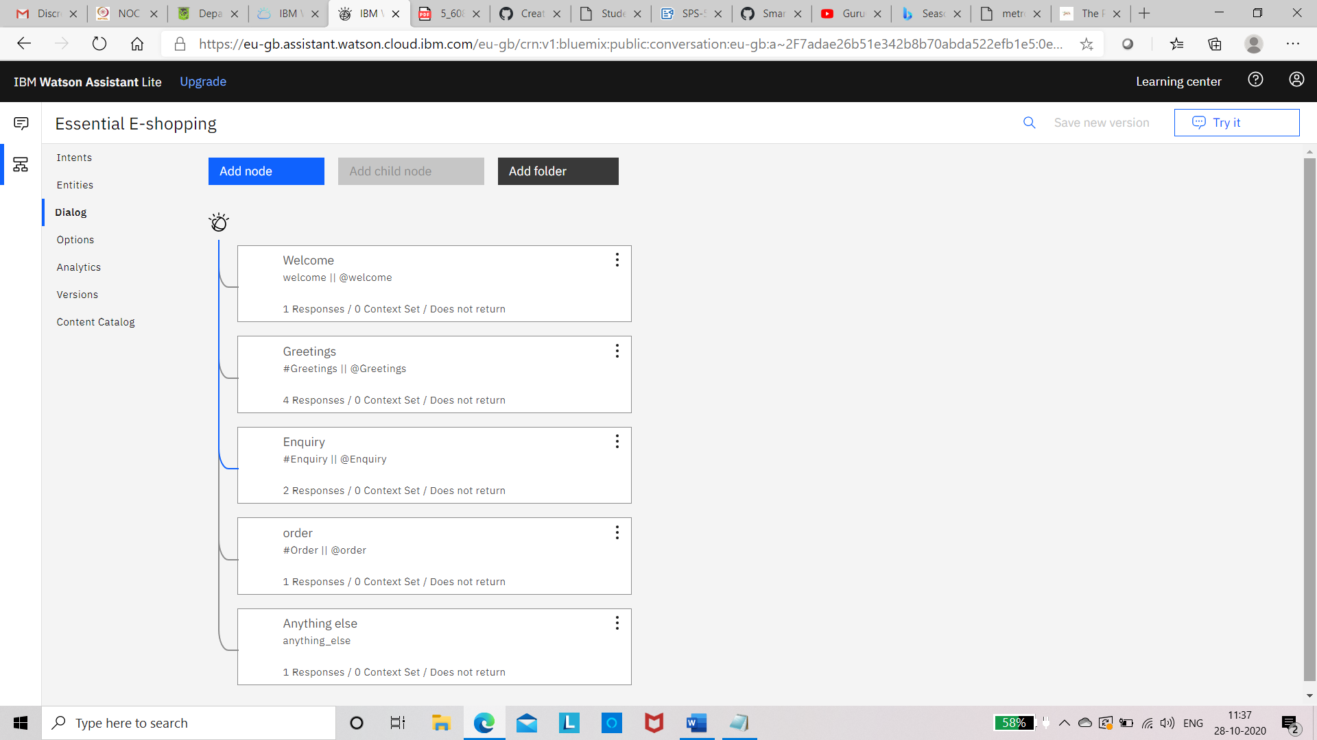

System entities

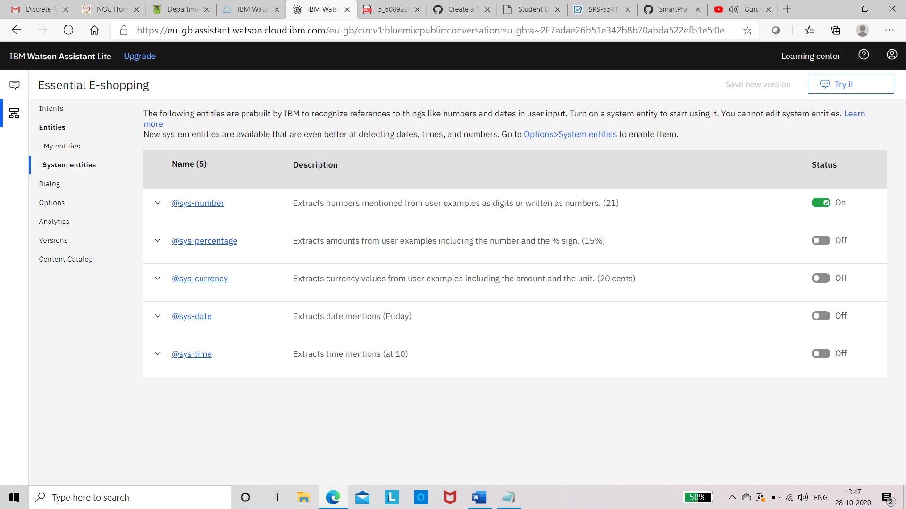

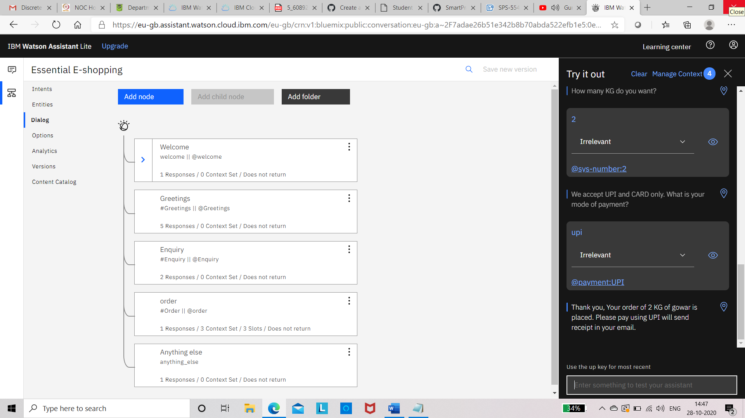

Creation of preview Link

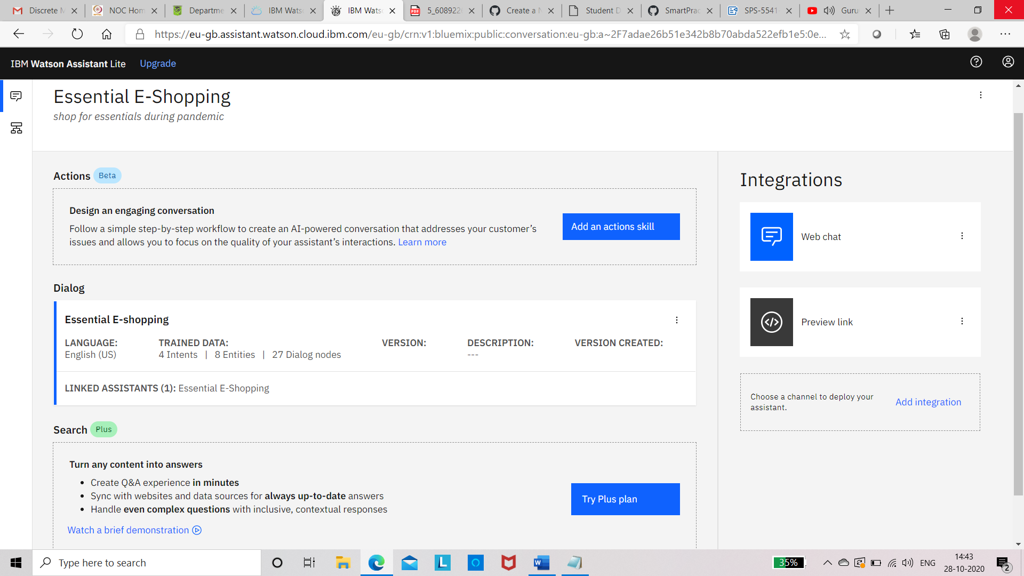

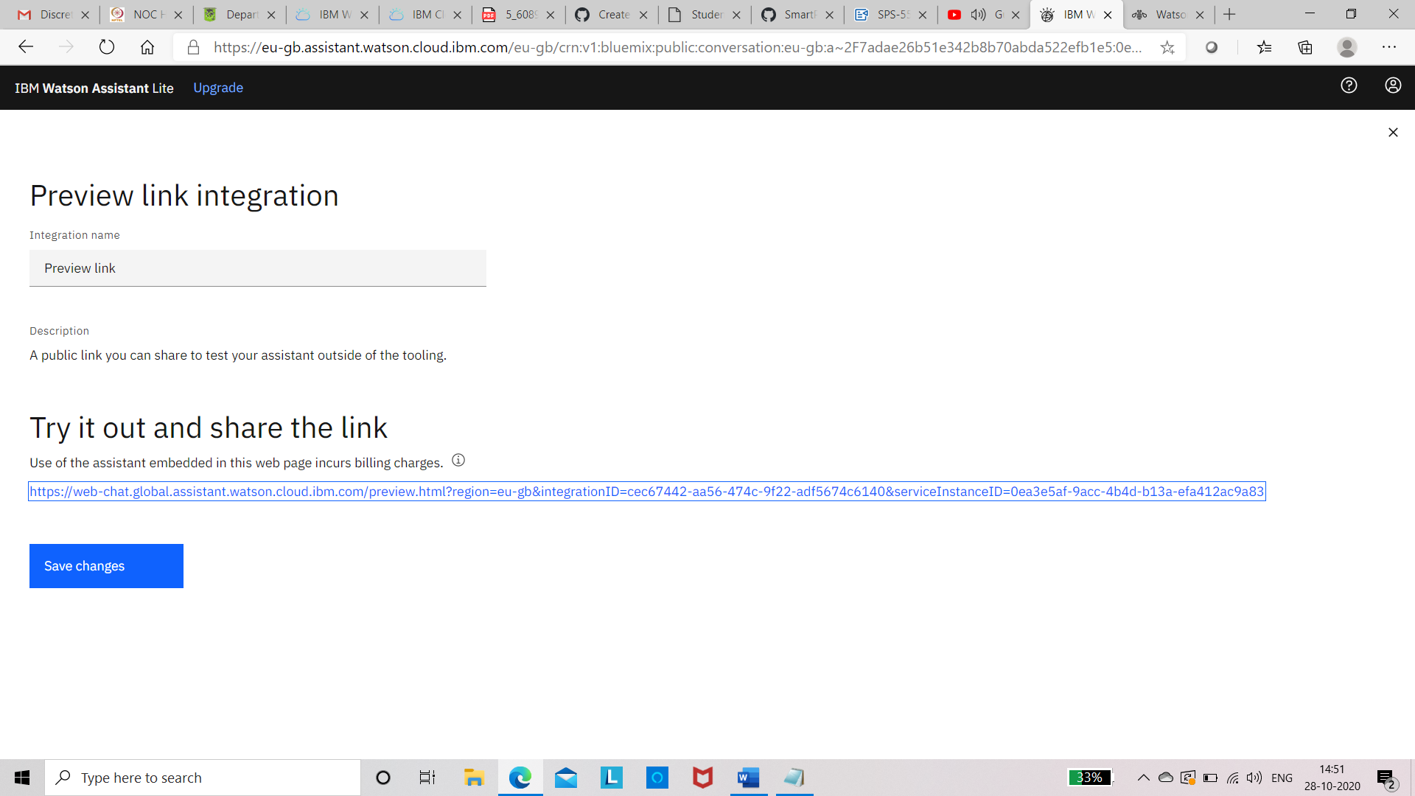

Result screen shots

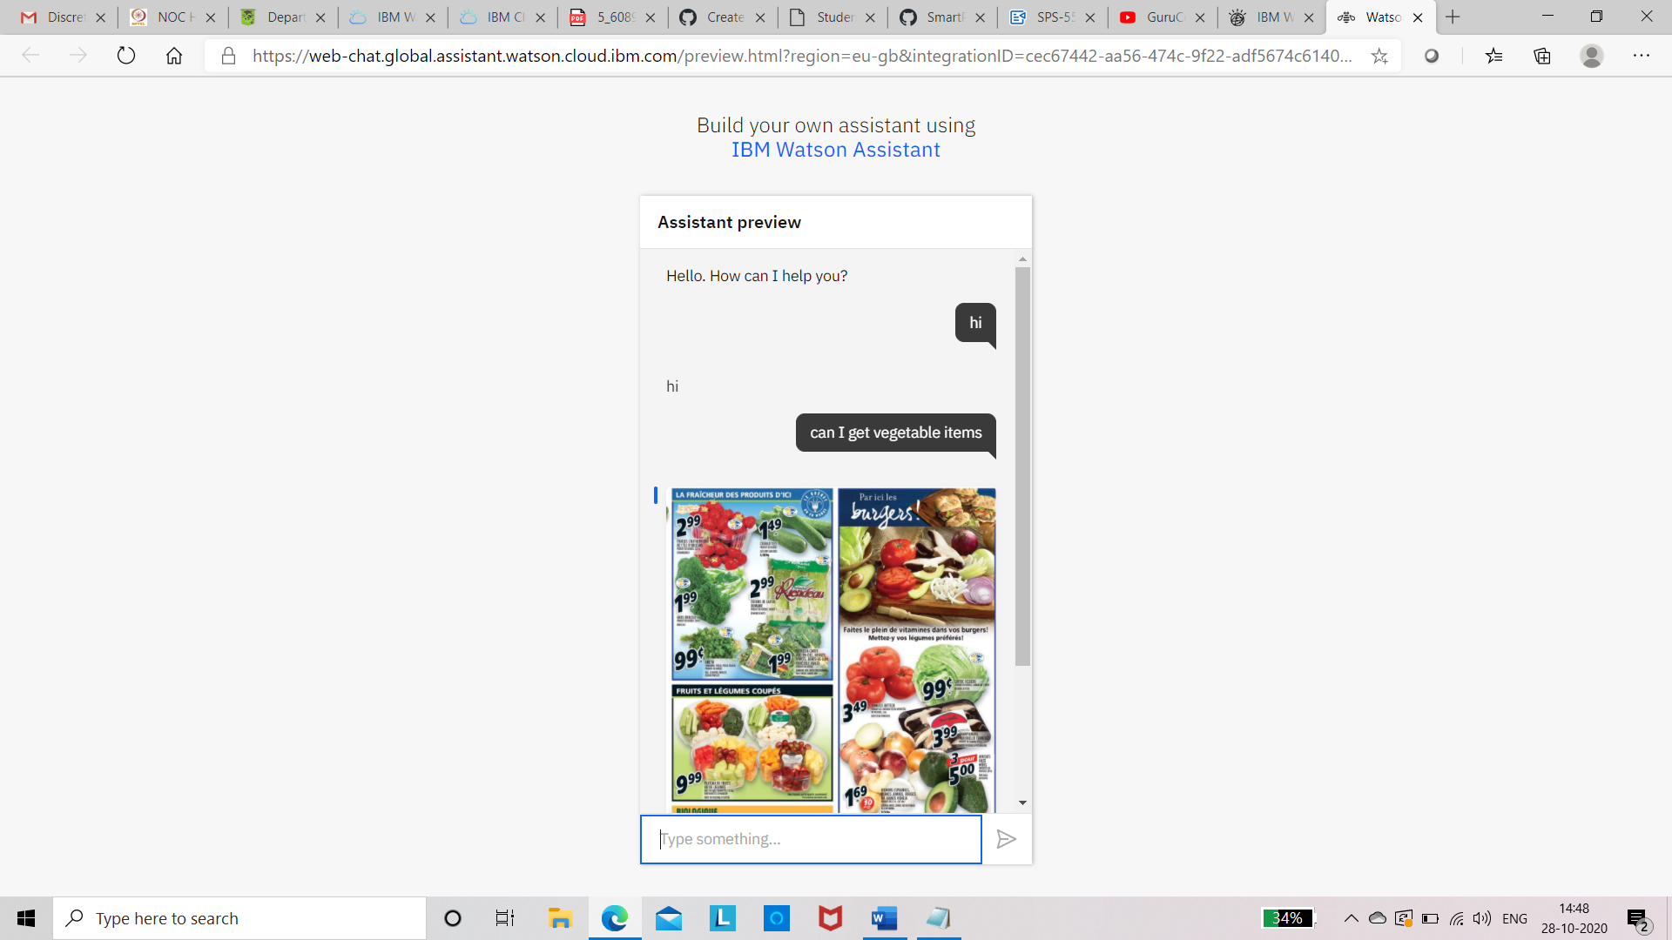

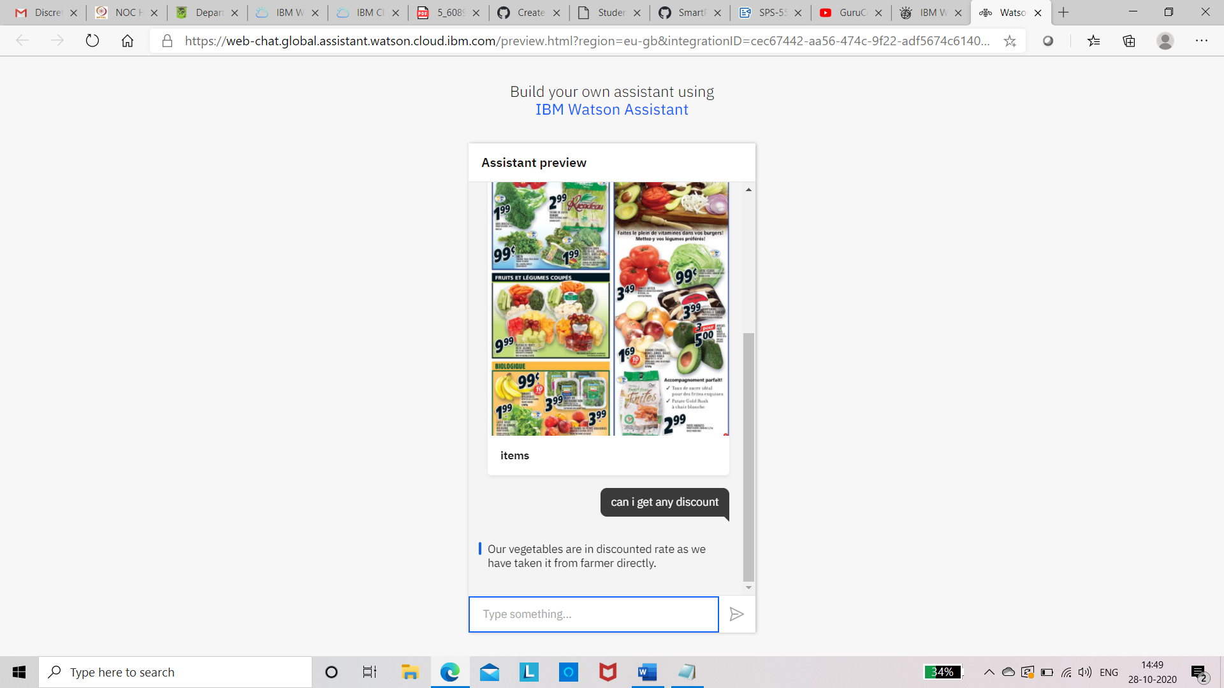 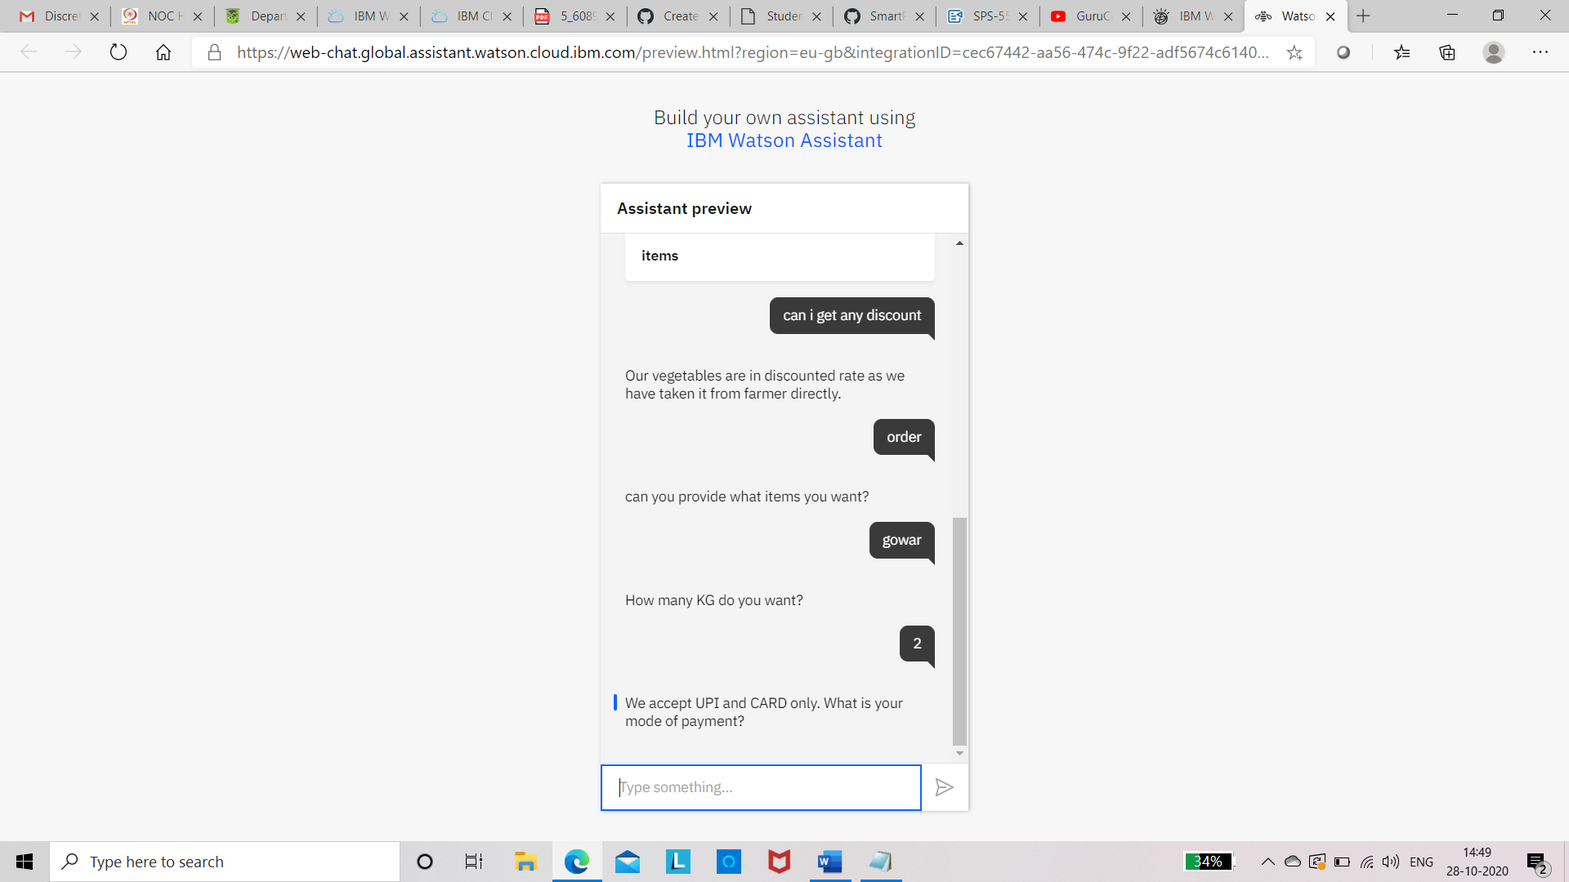 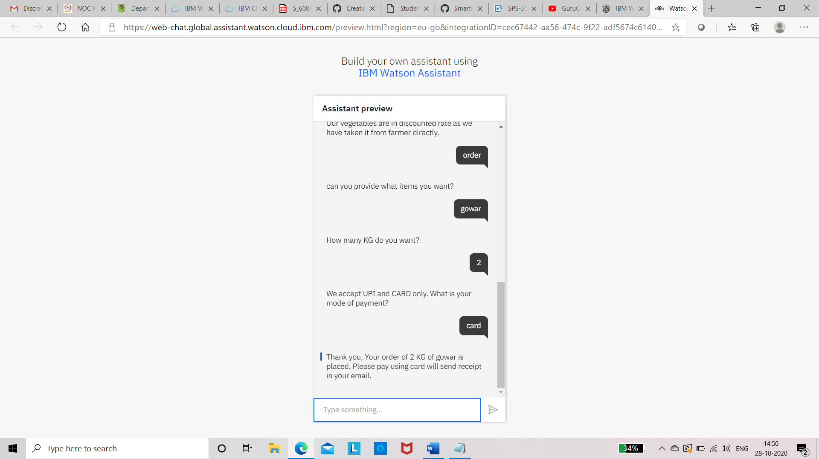

Integration with Node-red

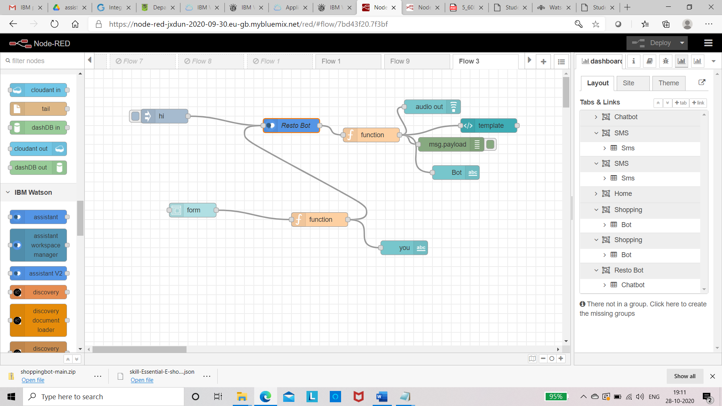

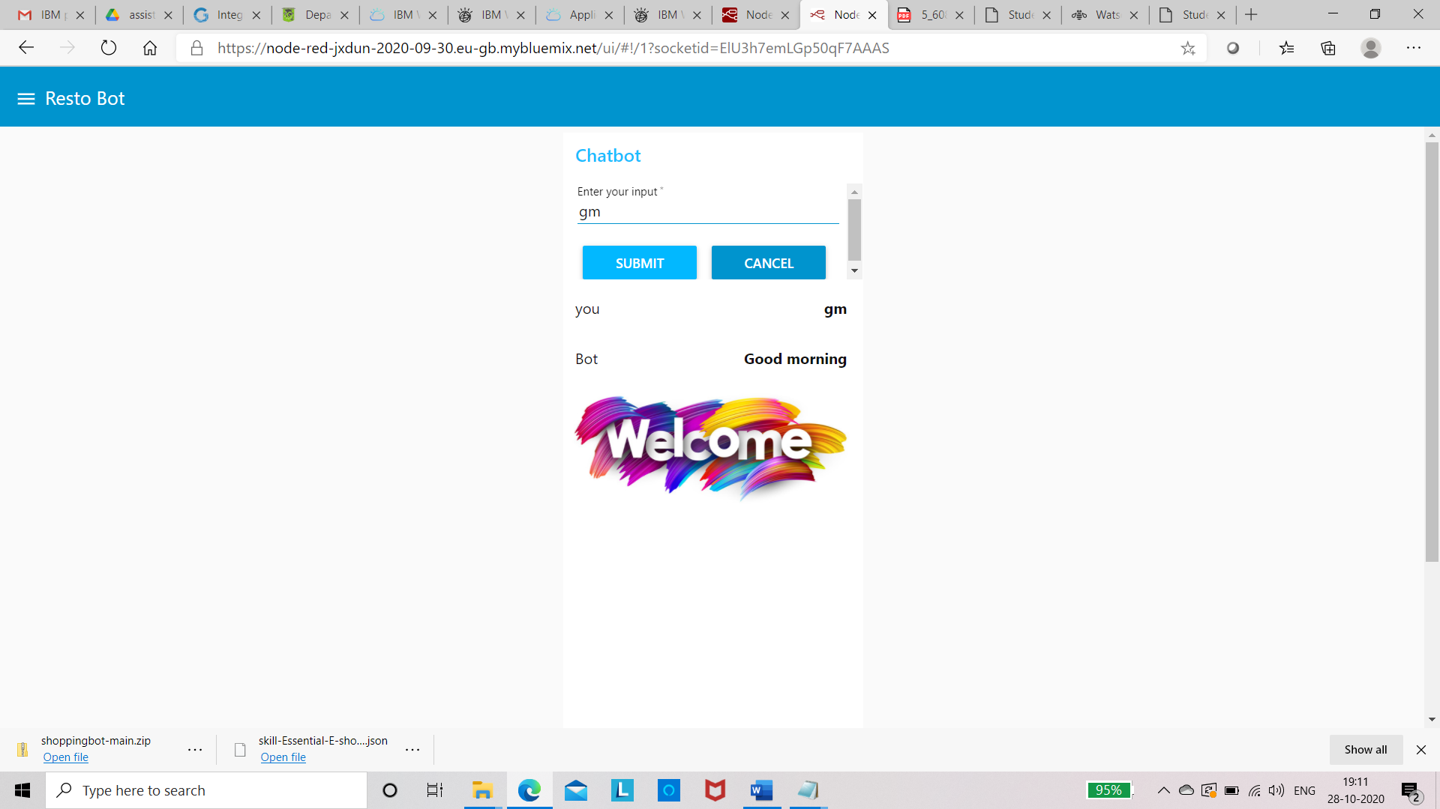

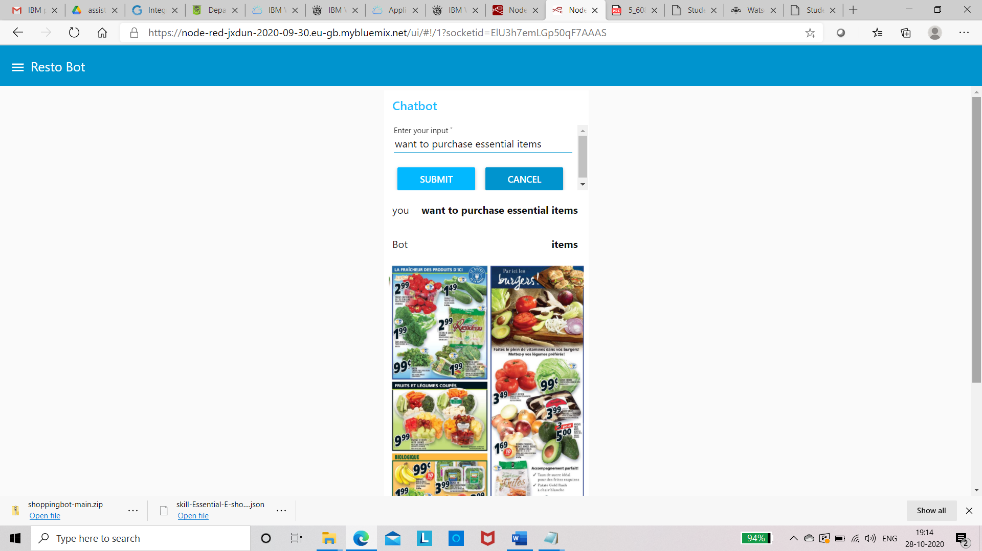

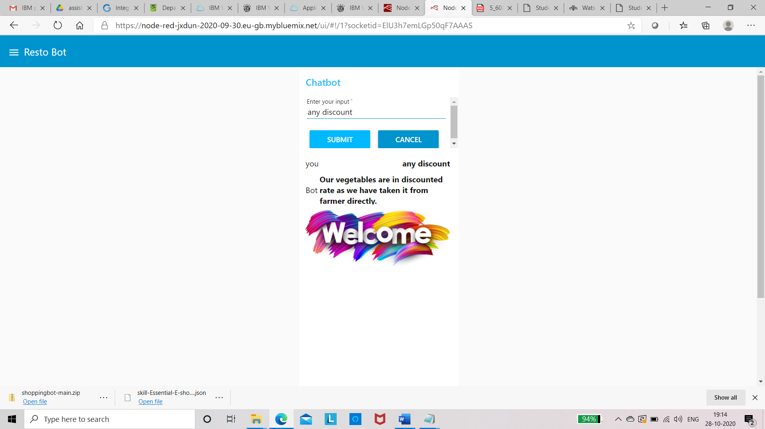

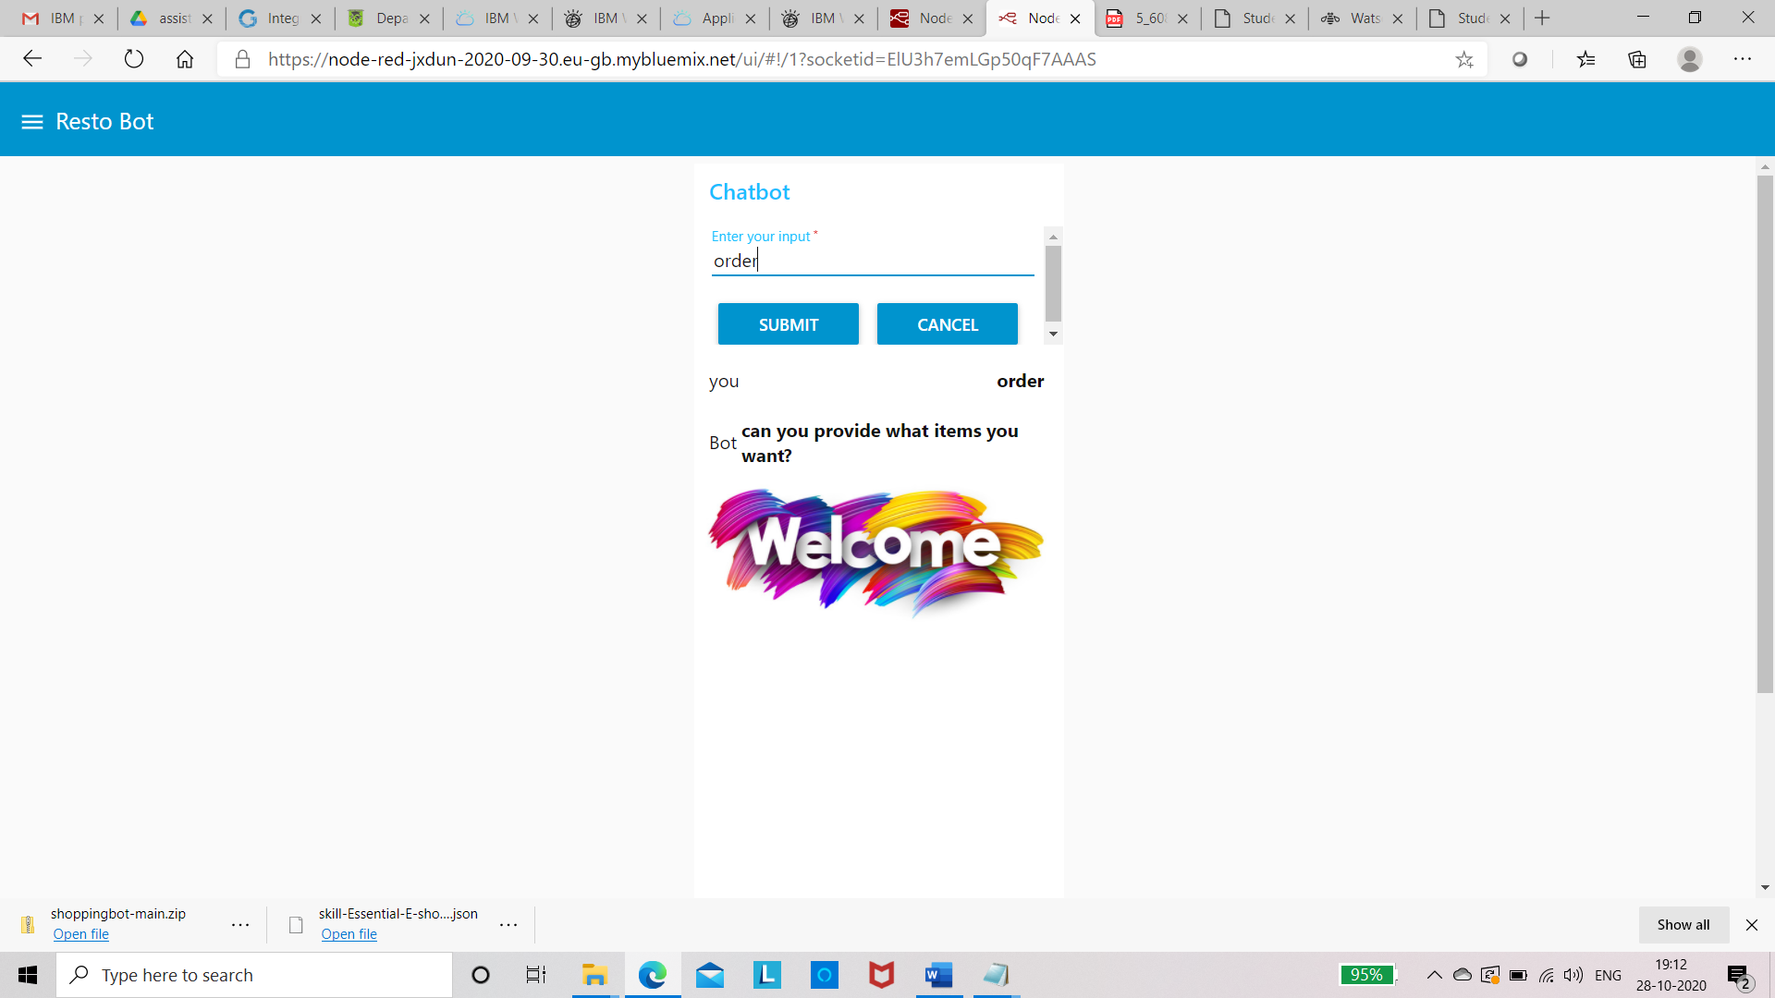

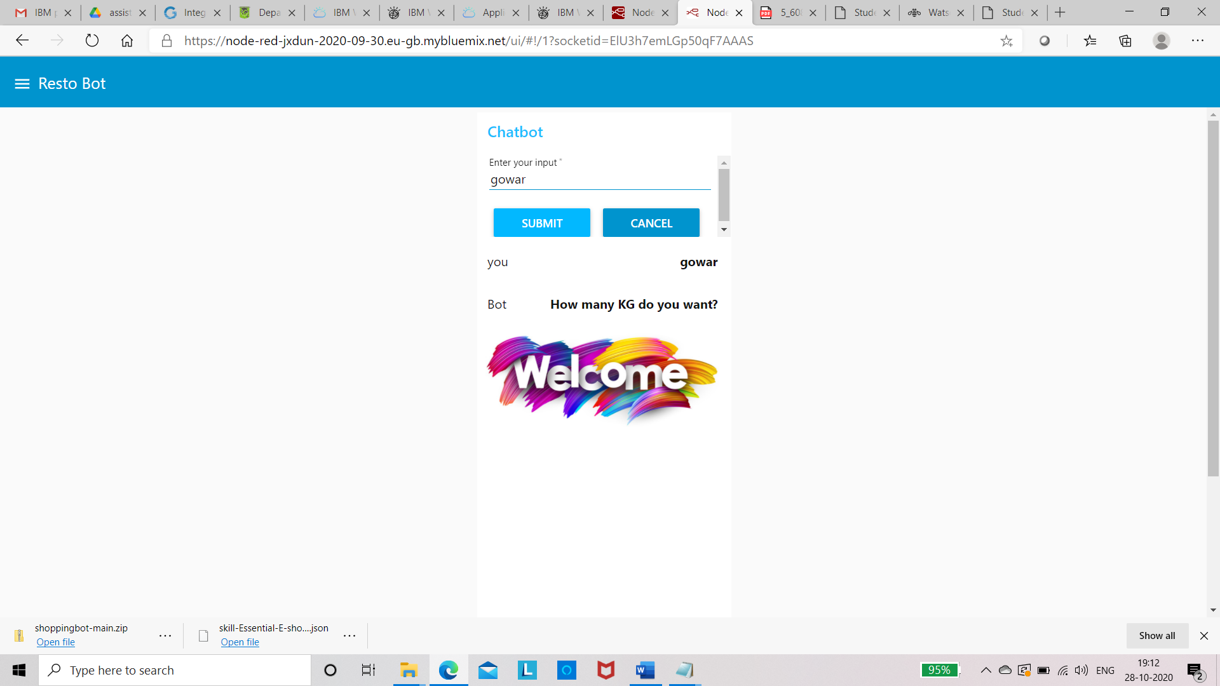

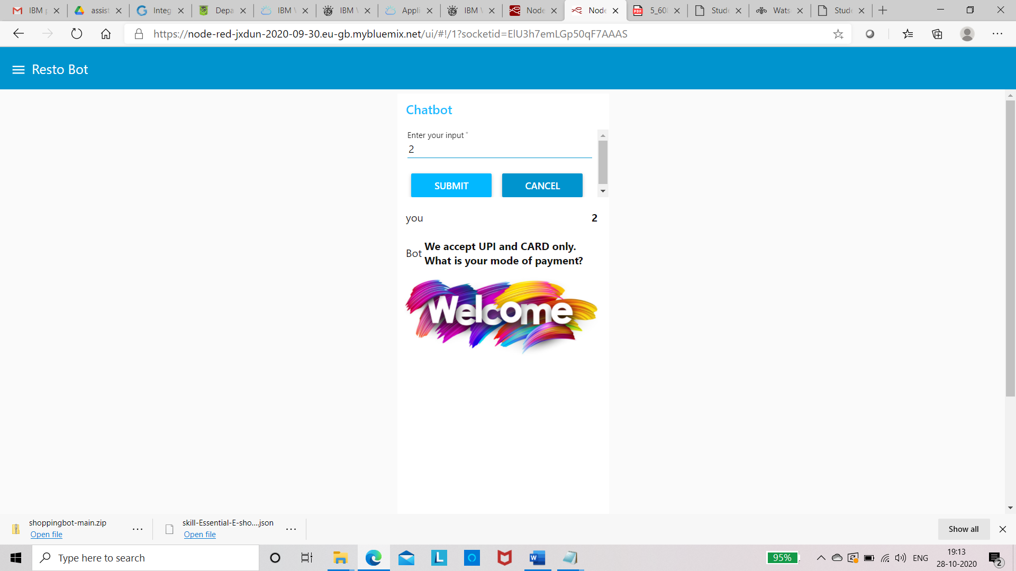

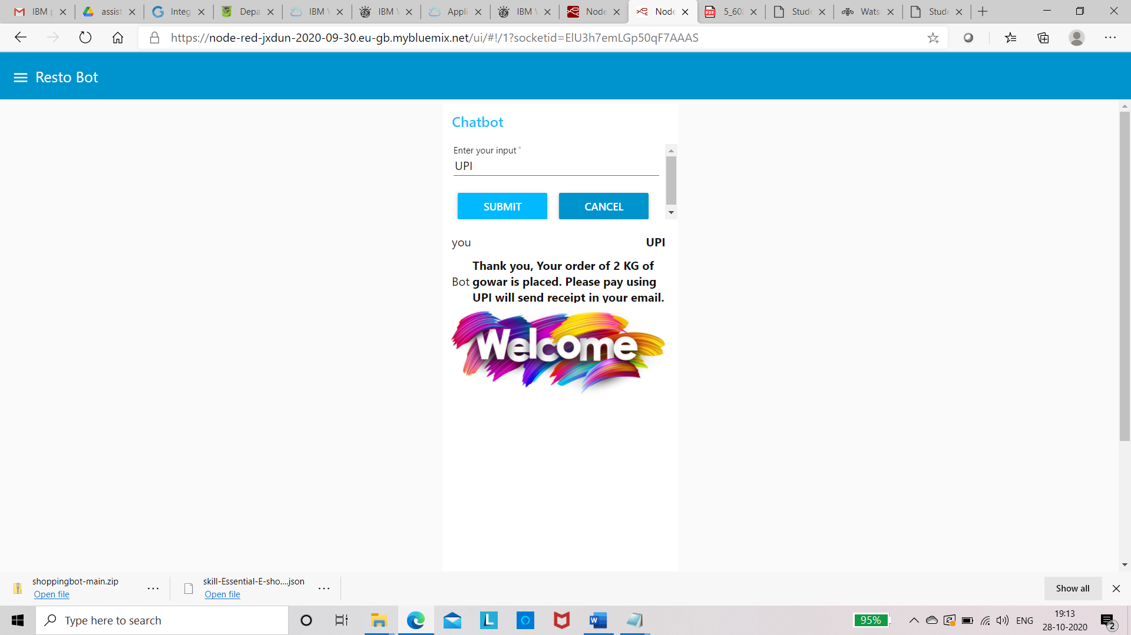

Conclusion - The problem is, most chatbots try to mimic human interactions, which can frustrate users when a misunderstanding arises. Watson Assistant is more. Watson Assistant will determine whether to provide a direct answer or reference search results from a document or database. In this project, I explore more prominent use of IBM cloud services for Essential E-shopping in this pandemic situation.